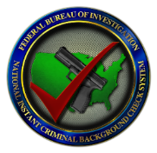

National Instant Criminal Background Check

System (NICS) Section

NICS Denial Notification Act of 2022

The Consolidated Appropriations Act of 2022 (hereinafter “Act”) was signed into law on March 15, 2022. Section 1011 of the Act included the “NICS Denial Notification Act of 2022.” The Act requires the Attorney General to report background check denials to state authorities and will require the FBI CJIS Division’s NICS Section to notify state, local, or tribal law enforcement of all FBI NICS denied transactions within 24 hours beginning October 1, 2022. The notification will include the date and time of the denial, the reason for the denial, the location of the federal firearms licensee (FFL), and the identity of the individual. If at any time the original denial is changed to a proceed, an updated notification to those agencies originally notified will be required.

**UNCLASSIFIED**

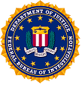

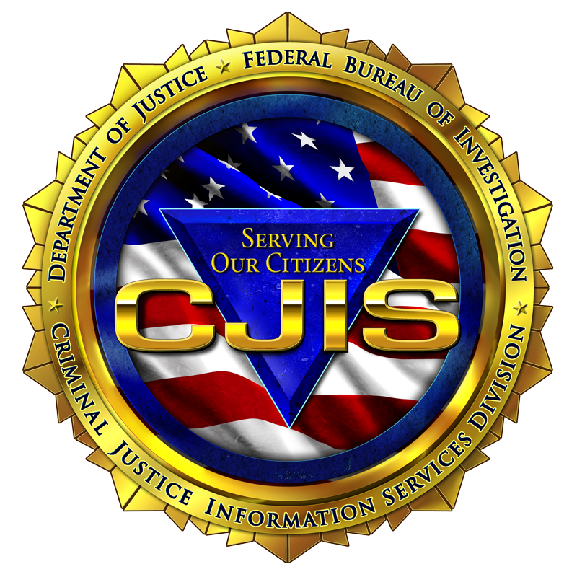

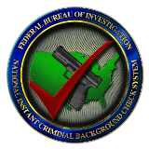

**UNCLASSIFIED**

Notification Process

Denial notifications will be delivered to the appropriate law enforcement agency based on the city, state, county, and zip code combination of the FFL’s location and the city, state, county, and zip code combination of the attempted transferee’s home address when different. Denial notifications will be delivered via an NCIC $.H.NDN unsolicited message. The use of the International Justice and Public Safety Information Sharing System Network’s administration message, commonly know as the Nlets AM, is available for states who cannot deliver the $.H.NDN unsolicited message to law enforcement agencies at this time.



**Attempted Transferee**



**Denied by NICS**

**Notification to law enforcement**

Deconfliction Information Information

All available information relating to the denial is delivered in the notification. The NICS Section is unable to provide additional information relating to the individual or the record related to the reason for the denial.

Visit www.FBI.gov for more information

The Bureau of Alcohol, Tobacco, Firearms and Explosives actively investigates certain denials made based on federal prohibitions. The NICS denial notifications are delivered containing a caveat to assist with potential deconfliction that could be needed for investigation prior to an agency taking any necessary action. State, local, or tribal agencies may also have deconfliction procedures in place that agencies should consider as well. There is no legislative requirement for any action placed on the receiving agency, and the NICS Section is not requesting any action to be taken based on receipt of a denial notification. Each state and/or agency is responsible for establishing any necessary policy/procedure related to the denial notifications in accordance with their authorities. To determine if your state has a policy in place, contact your respective CJIS systems agency or local agency administration for proper guidance and handling of the denial notification received.

Created by: The NICS Business and Liaison Unit/ July 2022

**UNCLASSIFIED**



**UNCLASSIFIED**

**UNCLASSIFIED**

The following is the denial notification that will be received when an individual is denied the attempted transfer of a firearm:

**************************************************************************

FIREARM DENIAL NOTICE:

A PERSON PURCHASING/RESIDING IN YOUR JURISDICTION WAS RECENTLY DENIED THE TRANSFER OF HANDGUN

**************************************************************************

THE FBI ENCOURAGES YOU TO CONTACT YOUR LOCAL BUREAU OF ALCOHOL, TOBACCO, FIREARMS AND EXPLOSIVES OFFICE PRIOR TO TAKING ACTION. CHARLESTON ATF, 304-234-5678

THE NATIONAL INSTANT CRIMINAL BACKGROUND CHECK SYSTEM (NICS) SECTION CONDUCTED A NAME SEARCH USING

DESCRIPTIVE DATA, NOT FINGERPRINTS, FOR A FIREARM BACKGROUND CHECK WHICH WAS DENIED ON 4/26/2022, 02:02:23PM

FOR:

NAME: DOE, JOHN L. NTN: 102356748

SEX: M RACE: W DATE OF BIRTH: 10-11-1990 PLACE OF BIRTH: WV

HEIGHT: 6’1’’ WEIGHT: 185 SOCIAL SECURITY NUMBER: 123-45-6789

RESIDENCE ADDRESS: 456 AMERICAN WAY, APPLE PIE, APPLE PIE COUNTY, WV 22445

INFORMATION RECEIVED INDICATES THE ATTEMPTED PURCHASER IS PROHIBITED FROM RECEIVING OR POSSESSING FIREARMS IN THE STATE OF PURCHASE AND/OR STATE OR RESIDENCE, BASED ON:

SUBJECT OF QUALIFYING PROTECTION ORDER

THE ATTEMPTED PURCHASE OCCURRED AT:

FIREARM DEALER: USA ARMS

ADDRESS: 123 MAIN STREET, HOMETOWN, HOMETOWN COUNTY WV, 23456

PHONE: 304-625-1002

SHOULD YOU HAVE QUESTIONS REGARDING THIS NOTIFICATION, PLEASE VISIT: (Web address will be inserted when established WWW.FBI.GOV)

THIS NOTIFICATION WAS ALSO PROVIDED TO THE FOLLOWING ORI(S):

WV0470150 SO APPLE PIE COUNTY 304-478-0000

WV0625630 PD HOMETOWN 304-457-0000

Example Denial Notification

National Instant Criminal Background Check

System (NICS) Section

Created by: The NICS Business and Liaison Unit/ July 2022